The Islamia University of Bahawalpur
Department of Computer Science



SOFTWARE DESIGN DESCRIPTION
(SDD DOCUMENT)
for

Car Wash Appointment

Version 1.0

By
Tania Ajmal
F22BINFT1E02057
Session Fall 2022 – 2026

Supervisor
Mam Sara Farid

Table of Contents
Introduction 1
Design methodology and software process model 1
System overview 1
Design models [along with descriptions] 1
Data design 2
Algorithm & Implementation 2
Software requirements traceability matrix 2
Human interface design 3
Appendix I 3

Revision History

Name | Date | Reason for changes | Version

Application Evaluation History

Comments (by committee)  *include the ones given at scope time both in doc and presentation | Action Taken

Supervised by
Mam Sara Farid

Signature

Introduction
This Software Design Document (SDD) outlines the design and architecture of the Car Wash Appointment mobile application, a user-centric platform designed to streamline the car wash experience. The application aims to provide car owners with a convenient and efficient way to book and manage their car wash appointments, eliminating the need for phone calls or in-person visits. Key features include real-time appointment scheduling, personalized preferences, push notifications for reminders and updates, secure payment integration, and a user-friendly interface for seamless navigation. This document will detail the system architecture, data models, user interface design, and implementation strategies to ensure the successful development of a robust and scalable application that meets the evolving needs of both car owners and car wash businesses.

Design methodology and software process model
Design Methodology: Object-Oriented Programming (OOP)
  - Modularity: OOP promotes code reusability through classes and objects, making the application easier to maintain and extend.
  - Flexibility: New features can be added or existing ones modified without significantly impacting other parts of the system.
  - Data Abstraction: Encapsulation within objects helps protect data integrity and reduces the risk of unintended side effects.
  - Inheritance: Allows for creating new classes (e.g., different types of users) by inheriting properties and behaviors from existing ones.

Software Process Model:

  - Flexibility: Flexibility allows for adapting to changing requirements and incorporating user feedback throughout the development cycle.
  - Continuous Improvement: Regular reviews and retrospectives help the team identify areas for improvement and enhance the development process.
  - Increased Customer Satisfaction: Frequent delivery of working software ensures that the application meets user needs and expectations.
  - Improved Team Collaboration: Agile fosters a collaborative environment where team members work closely together and communicate effectively.

Using Java and Android Studio:
- Java is an object-oriented language, making it a perfect fit for the chosen OOP design methodology.
- Android Studio is the official Integrated Development Environment (IDE) for Android app development, providing a comprehensive set of tools ¹ for development, debugging, and testing.

System overview

This Car Wash Appointment mobile application is designed to revolutionize the way car owners schedule and manage their car wash services. Recognizing the increasing demand for convenience and efficiency in today's fast-paced world, this application aims to provide a user-friendly and accessible platform for both car owners and car wash businesses.
Functionality:
- User-centric Appointment Scheduling: Users can easily browse available appointment slots, select their preferred date and time, and book car wash services with just a few taps.
- Personalized Preferences: Users can save their preferred services (e.g., wash and wax, interior detailing), and payment methods for quicker future bookings.
- Real-time Availability: The application will display real-time availability of appointment slots, ensuring users can always find a convenient time that suits their schedule.
- Push Notifications: Users will receive timely push notifications for upcoming appointments, reminders, and special offers from their preferred car washes.
- Secure Payment Integration: The application will integrate with secure payment gateways to facilitate convenient and secure online payments for car wash services.
- User Reviews and Ratings: Users can easily rate and review their car wash experiences, providing valuable feedback to both the car wash businesses and other users.
Context:
The modern consumer increasingly demands convenience and digital solutions. This application addresses this need by providing a convenient and efficient alternative to traditional methods of booking car wash appointments, such as phone calls or in-person visits.
Design:
The application will be designed with a focus on user experience and usability. A clean and intuitive user interface will ensure easy navigation and effortless interaction. The application will be developed using Java and Android Studio, leveraging the power of Object-Oriented Programming for a robust and maintainable codebase.
Background:
The car wash industry is constantly evolving. This application aims to contribute to this evolution by introducing a technologically advanced solution that enhances customer satisfaction and streamlines operations for both car owners and car wash businesses.
This section provides a high-level overview of the Car Wash Appointment application, setting the stage for the more detailed design considerations discussed in subsequent sections of the SDD.

Architectural design

The Car Wash Appointment mobile application will follow a Model-View-Controller (MVC) architectural pattern. This pattern enhances code organization, maintainability, and testability.

Model:

Represents the data and business logic of the application.

Contains classes for:

User (user profiles, preferences)

Car Wash (locations, services, pricing)

Appointment (scheduling, booking details)

Data access layer (handling data storage and retrieval from local storage or a server)

View:

Responsible for the user interface (UI) of the application.

Contains classes for:

Activity classes (main activity, booking activity, profile activity)

Fragments (for different UI sections within an Activity)

XML layouts (defining the structure and appearance of UI elements)

Controller:

Acts as an intermediary between the Model and View.

Handles user interactions, updates the Model based on user input, and updates the View to reflect changes in the Model.

Diagram:

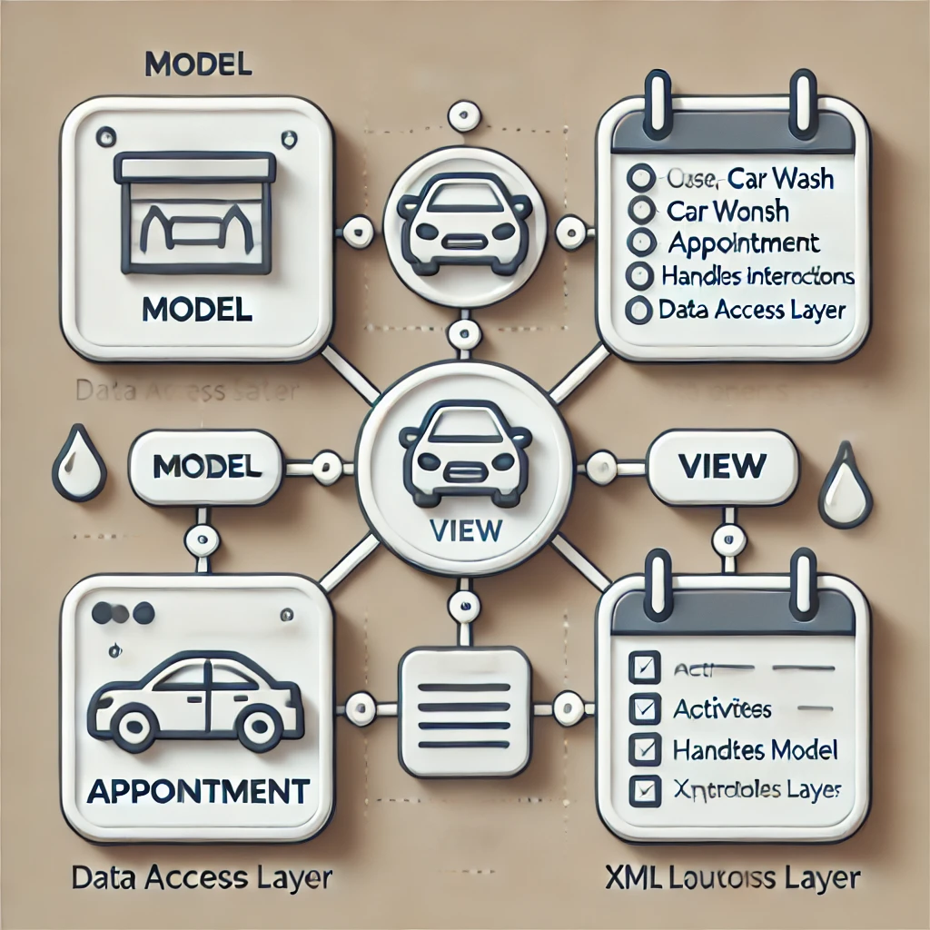

The diagram illustrates the Model-View-Controller (MVC) architectural pattern, a common design approach for software applications, particularly user interfaces. MVC promotes a separation of concerns, making the application more organized, maintainable, and easier to test.

Components:

Model:

This layer represents the core data and business logic of the application.

It includes classes such as:

User: Represents user profiles, preferences, and booking history.

Car Wash: Represents car wash locations, services offered, and pricing.

Appointment: Represents scheduled appointments, including date, time, and selected services.

Data Access Layer: Handles the interaction with data storage (e.g., local database, server).

View:

This layer is responsible for the user interface (UI) of the application.

It includes:

Activities: The main building blocks of Android applications, representing individual screens.

Fragments: Smaller, reusable UI components within an Activity.

XML Layouts: Define the structure and appearance of UI elements using XML.

Controller:

This layer acts as an intermediary between the Model and View.

It handles user interactions, updates the Model based on user input, and updates the View to reflect changes in the Model.

Interactions:

Model to Controller:

The Model provides data to the Controller when requested.

Controller to Model:

The Controller updates the Model with changes made by the user.

Controller to View:

The Controller passes data from the Model to the View for display.

View to Controller:

The View sends user input (e.g., button clicks, text entry) to the Controller.

Benefits of MVC:

Flexibility:

Changes to the UI can be made without affecting the underlying data or business logic.

Reusability:

Model components can potentially be reused in other parts of the application or even in other applications.

Testability:

Each component can be tested independently, making it easier to identify and fix bugs.

Process flow/Representation

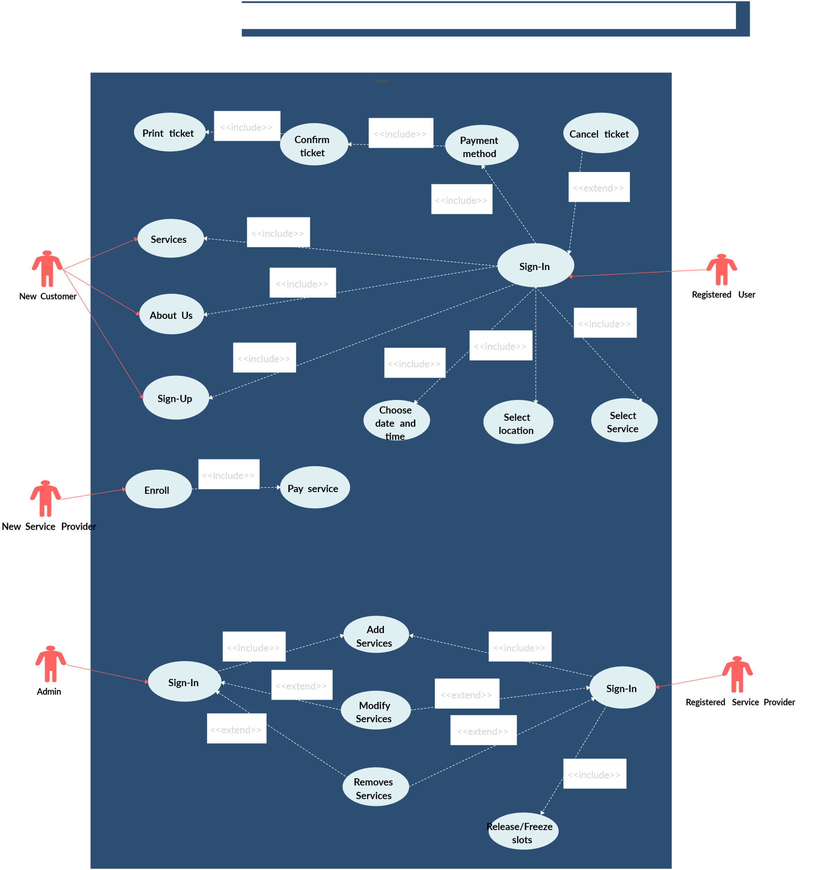

- Start: The application starts.
- User Registration/Login:
  - The user either registers a new account or logs in with existing credentials.
- Browse Car Washes:
  - The user browses available car wash locations, viewing their details, services, and pricing.
- Select Car Wash & Services:
  - The user selects a preferred car wash location and chooses the desired services (e.g., wash and wax, interior detailing).
- Schedule Appointment:
  - The user selects a preferred date and time for the appointment.
  - The system checks for availability and displays available slots.
- Confirm Appointment:
  - The user reviews the selected appointment details (date, time, services, and location).
  - The user confirms the appointment.
- Payment Processing:
  - The user selects a payment method (e.g., credit card, online wallet).
  - The system processes the payment securely.
- Appointment Confirmation:
  - The system confirms the appointment booking and sends a notification to the user.
- Push Notifications:
  - The system sends push notifications for appointment reminders, updates, and special offers.
- Manage Appointments:
- The user can view, reschedule, or cancel their appointments.
- Rate and Review:
- After the car wash service, the user can rate and review their experience.
- End: The application ends or the user continues to use the application.

Design models [along with descriptions]

The applicable models may include:
- Class Diagram
- Sequence Diagram
- State Transition Diagram
- Data Flow Diagram
- Schematic diagram (Hardware projects only)
- Timing diagram (Hardware projects only)
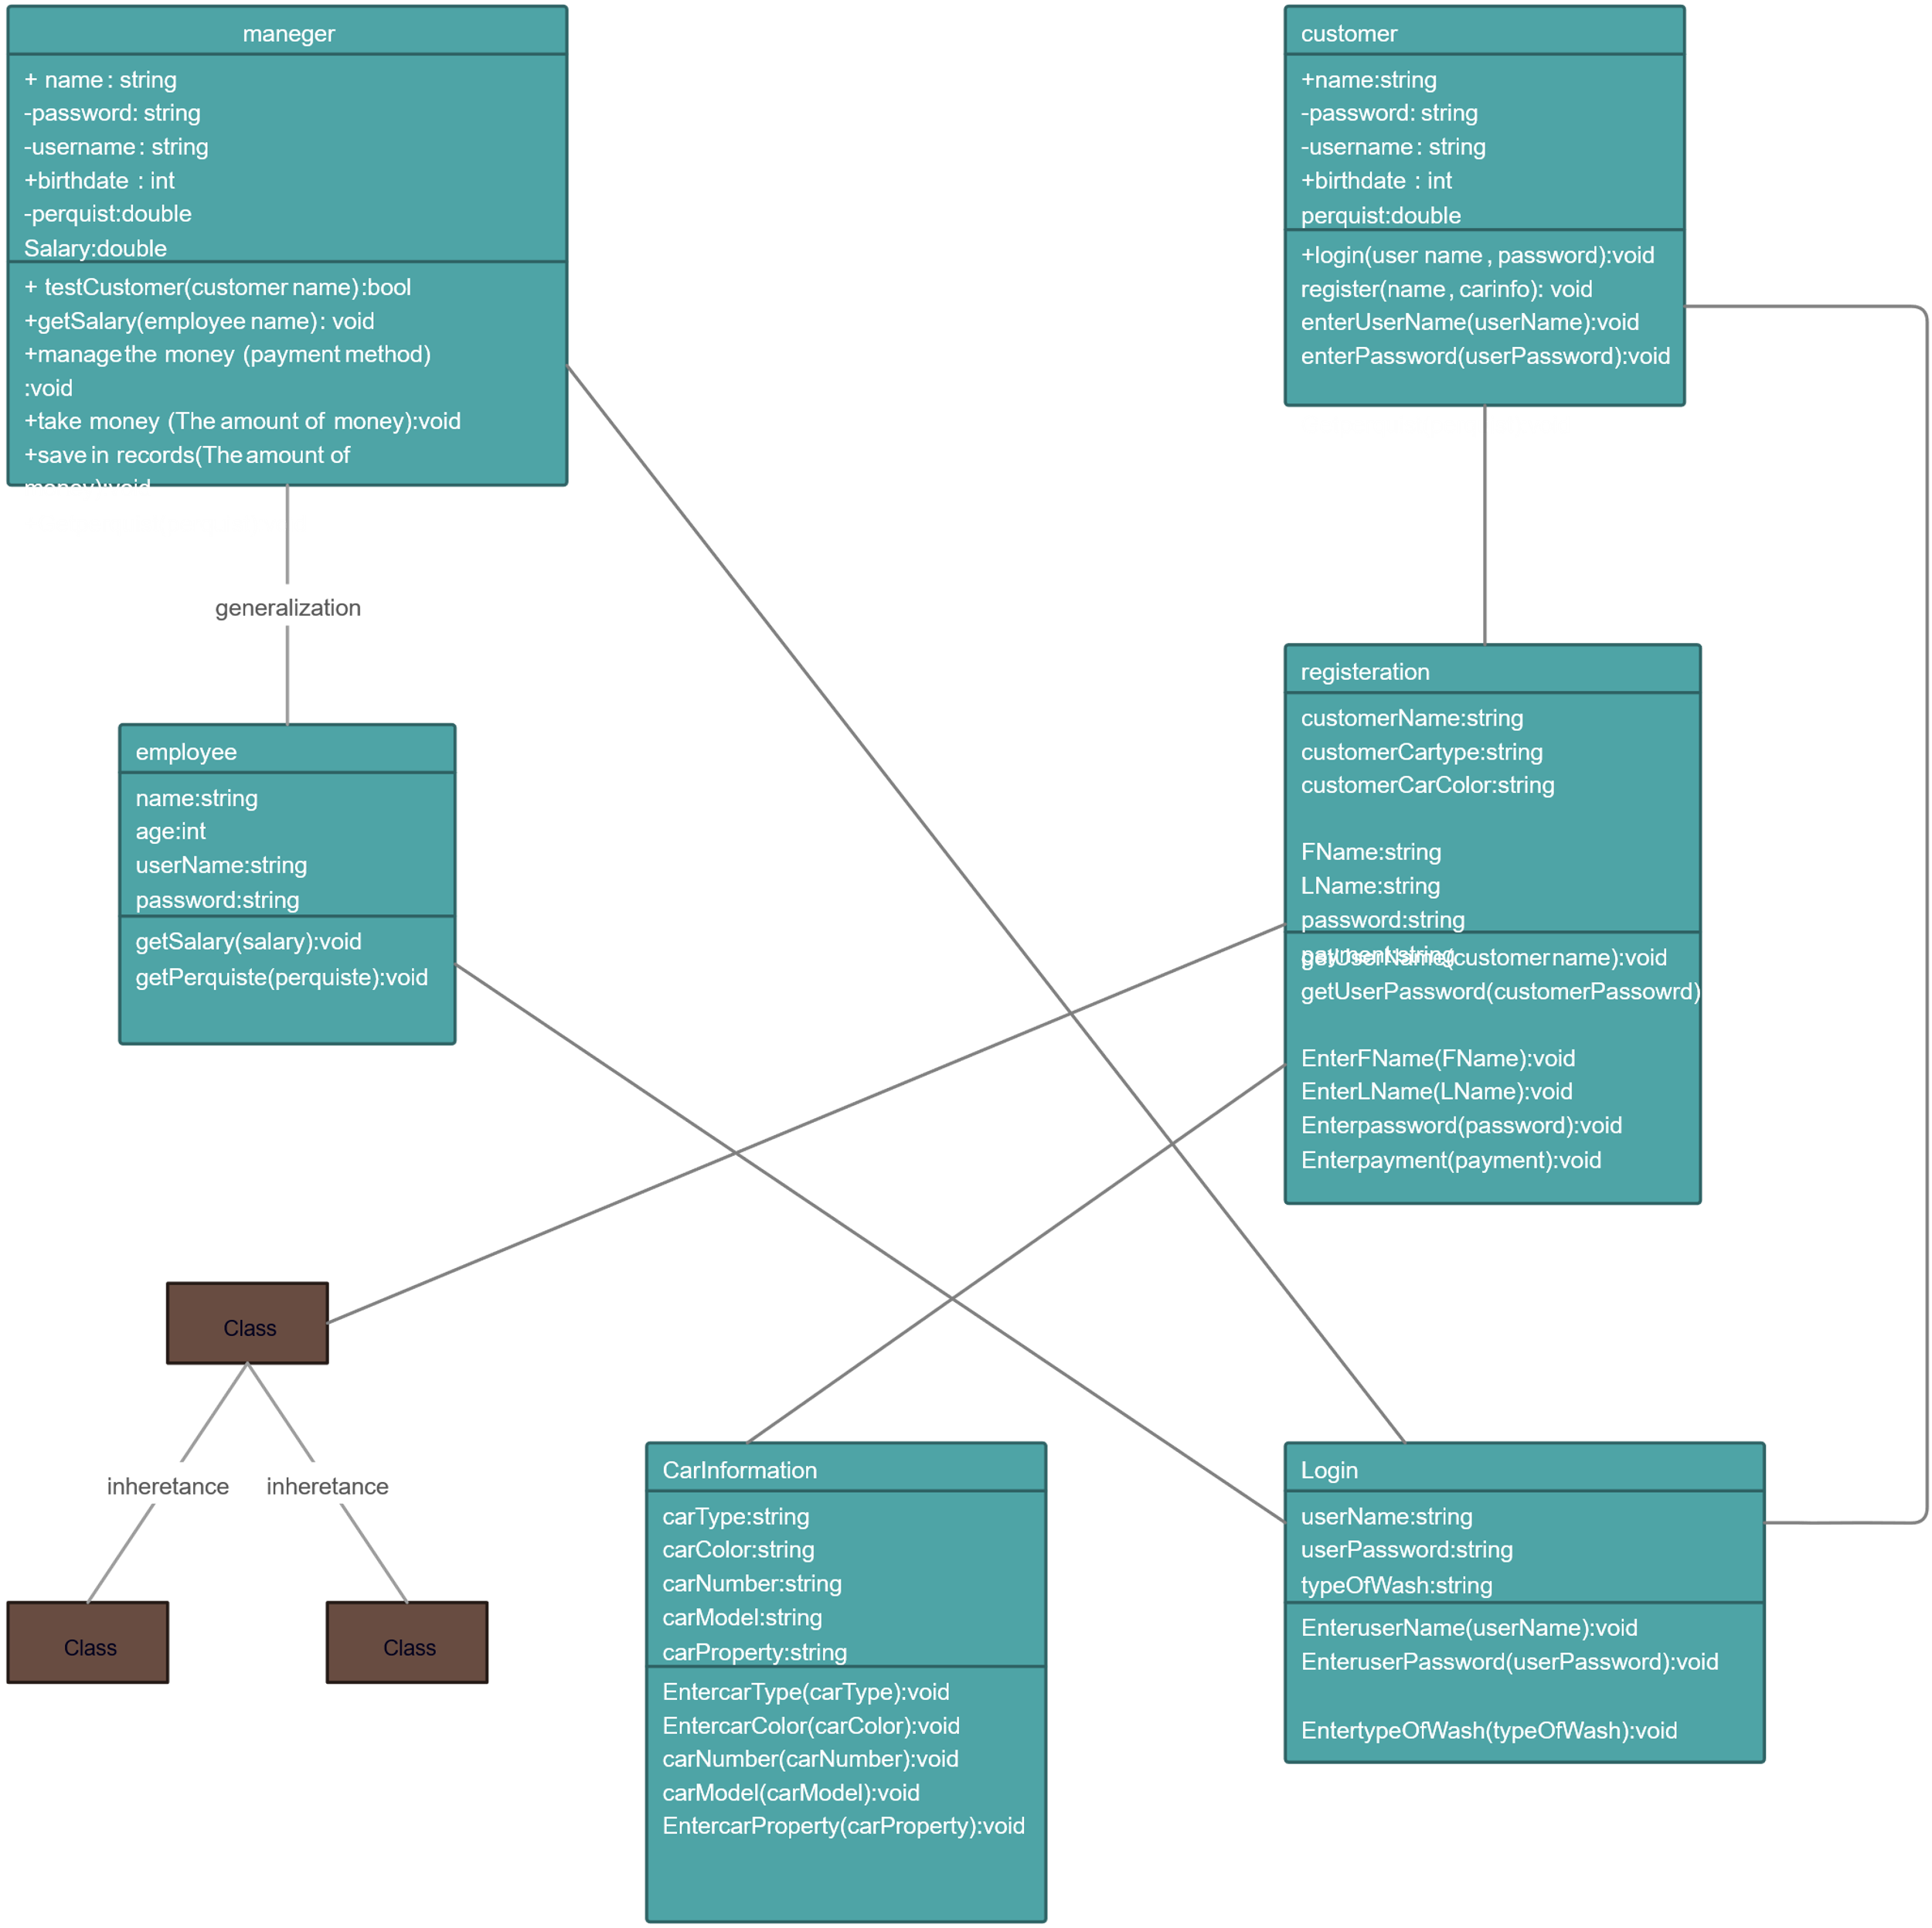

Classes:
- User:
  - Attributes: userId, name, email, phone, address, preferences (e.g., preferred car wash, preferred services), bookingHistory
  - Methods: register(), login(), updateProfile(), viewBookings(), cancelBooking()
- CarWash:
  - Attributes: carWashId, name, address, contact, services (List), prices, workingHours, rating
  - Methods: addService(), removeService(), updatePrices(), getAvailability()
- Appointment:
  - Attributes: appointmentId, userId, carWashId, date, time, services, status (e.g., booked, completed, canceled), price
  - Methods: book(), reschedule(), cancel(), getStatus()
- Notification:
  - Attributes: notificationId, userId, message, type (e.g., appointment reminder, special offer)
  - Methods: sendNotification()
Relationships:
- User - Appointment: One-to-many relationship. A User can have multiple Appointments.
- CarWash - Appointment: One-to-many relationship. A CarWash can have multiple Appointments.

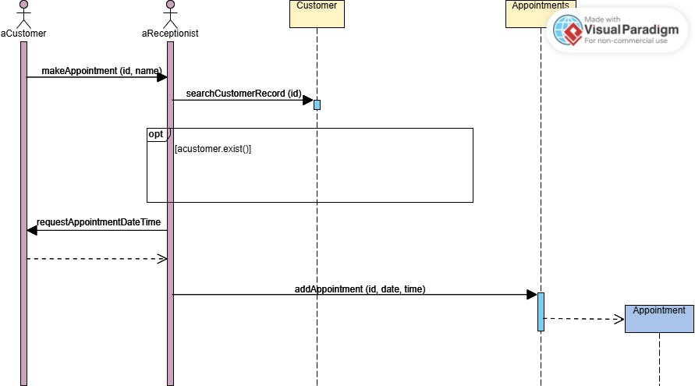

Explanation:
This diagram illustrates the sequence of interactions involved in booking an appointment:
- User: Initiates the booking process.
- View: Displays available car washes and their services.
- User: Selects a car wash and services.
- Controller: Retrieves car wash details and available slots from the Model.
- View: Displays available appointment slots to the user.
- User: Selects a preferred date and time.
- Controller: Creates an Appointment object with the selected details.
- Model: Stores the new Appointment in the database.
- Controller: Notifies the View of successful booking.
- View: Displays a confirmation message to the user.
Justification for Model Choice:
- Class Diagram: This diagram provides a static view of the system, showing the classes, their attributes, and the relationships between them. It helps in understanding the structure and organization of the application.
- Sequence Diagram: This diagram illustrates the dynamic behavior of the system by showing the sequence of interactions between objects during a specific use case (booking an appointment). It helps in understanding the flow of control and data within the application.

Data design

Data Structures:

User:

userId: Unique identifier (e.g., UUID)

name: String

email: String

phone: String

address: String

preferences: JSON object (e.g., { "preferredCarWashId": "cw123", "preferredServices": ["wash", "wax"] })

bookingHistory: List of Appointment IDs

CarWash:

carWashId: Unique identifier (e.g., UUID)

name: String

address: String

contact: String

services: List of Strings (e.g., ["wash", "wax", "detailing"])

prices: JSON object (e.g., { "wash": 10.0, "wax": 5.0, "detailing": 20.0 })

workingHours: JSON object (e.g., { "mon": "09:00-18:00", "tue": "09:00-18:00", ... })

rating: Float (average rating)

Appointment:

appointmentId: Unique identifier (e.g., UUID)

userId: Foreign key referencing User table

carWashId: Foreign key referencing CarWash table

date: Date

time: Time

services: List of Strings

status: String (e.g., "booked", "completed", "canceled")

price: Float

2. Data Storage:

Database: A mobile-friendly database like SQLite will be used for local data storage.

Advantages: Fast local access, offline functionality, reduced reliance on network connectivity.

3. Data Processing and Organization:

Data Persistence:

User data, car wash information, and appointment details will be stored in the SQLite database.

Data will be persisted locally on the user's device.

Data Retrieval:

The application will retrieve data from the database as needed.

For example, when the user views a list of car washes, the application will query the database to retrieve the relevant car wash information.

Data Updates:

The application will update the database with changes made by the user (e.g., booking an appointment, updating profile information).

4. Data Security:

Local Storage Security:

SQLite databases can be secured using file system permissions to restrict access.

This data design will ensure:

Efficient data storage and retrieval:

The use of SQLite provides fast and efficient local data access.

Offline functionality:

Users can access and use the application even when offline.

Data security:

Secure storage mechanisms will protect user data.

Scalability:

The data design can be adapted to accommodate future growth and additional features.

Data dictionary

Entity | Type | Description | Attributes | Methods
Appointment | Object | Represents a scheduled car wash service | appointmentId (String), userId (String), carWashId (String), date (Date), time (Time), services (List<String>), status (String), price (Float) | book(), reschedule(), cancel(), getStatus()
Carwash | Object | Represents a car wash location. | carWashId (String), name (String), address (String), contact (String), services (List<String>), prices (Map<String, Float>), workingHours (Map<String, String>), rating (Float) | addService(), removeService(), updatePrices(), getAvailability()
Notification | Object | Represents a push notification sent to the user. | notificationId (String), userId (String), message (String), type (String) | sendNotification()
User | Object | Represents an application user. | userId (String), name (String), email (String), phone (String), address (String), preferences (Map<String, Object>), bookingHistory (List<String>) | register(), login(), updateProfile(), viewBookings(), cancelBooking()
• Data Types:
- String: Represents text data.
- Date: Represents a date.
- Time: Represents a time.
- Float: Represents a floating-point number (for prices and ratings).
- List: Represents an ordered collection of items.
- Map: Represents a collection of key-value pairs.
• Relationships:
- User - Appointment: One-to-many. A User can have multiple Appointments.
- Car Wash - Appointment: One-to-many. A Car Wash can have multiple Appointments.
• Methods:
- The listed methods represent some of the key functionalities associated with each object.
- Method parameters are not explicitly listed in this table for brevity. However, you can add them to the Data Dictionary for more detailed documentation.

Algorithm & Implementation
1. User Object
- register ()
- 1. Validate user input (email, password, etc.)
- 2. Store user data in the database
- login ()
- 1. Retrieve user credentials from the input fields
- 2. Validate user input
- 3. Retrieve user data from the database based on email
- 4. If successful, authenticate the user and store user session data
- updateProfile()
- 1. Retrieve updated user information
- 2. Validate user input
- 3. Update user data in the database
- 4. Update user session data with new information
- viewBookings()
- 1. Retrieve the user's booking history from the database
- 2. Display the list of appointments to the user
- cancelBooking()
- 1. Retrieve the appointment details
- 2. Update the appointment status to "canceled" in the database
2. CarWash Object
- addService()
- 1. Validate the new service name
- 2. Add the new service to the list of services
- 3. Update the CarWash object in the database
- removeService()
- 1. Validate the service to be removed
- 2. Remove the service from the list of services
- 3. Update the CarWash object in the database
- updatePrices()
- 1. Validate the new prices for each service
- 2. Update the prices in the CarWash object
- 3. Update the CarWash object in the database
- getAvailability()
- 1. Check the working hours for the specified date and time
- 2. Check for existing appointments during the requested time slot
- 3. Return a list of available time slots

3. Appointment Object
- book()

1.Validate the appointment details (date, time, services)
- 2. Check for car wash availability using the CarWash.getAvailability() method
- 3. Calculate the total price based on selected services
- 4. Create a new Appointment object
- 5. Store the Appointment object in the database
- reschedule()
- 1. Retrieve the existing appointment details
- 2. Validate the new date and time
- 3. Check for car wash availability for the new time slot
- 4. Update the appointment date and time in the database
- cancel()
- 1. Update the appointment status to "canceled" in the database
- getStatus()
- 1. Retrieve the current status of the appointment from the database
2. Return the status

Software requirements traceability matrix
This section should contain a table that summarizes how each software requirement has been met in this document. The tabular format permits one-to-one and one-to-many relationships to be shown.
Table 7 Requirements Traceability Matrix
Req. Number | Ref. Item | Design Component | Component Items
FR01 | User registration | Class Diagram | User Class
FR2 | User Login | Class Diagram | User Class
FR03 | User profile Management | Class Diagram | User Class
FR04 | View Available Car Washed | Class Diagram | Carwash Class
FR05 | Book Appointment | Class Diagram | Appointment Class
FR06 | View Appointment History | Class Diagram | User Class
FR07 | Receive Notification | Class Diagram | Notification Class
FR08 | Secure Payment Integration | Sequence Diagram | Payment Gateway integration
FR09 | Offline Functionality | Data Design | SQL LITE Databas

Human interface design

1. User Perspective:
The Car Wash Appointment mobile application is designed to be intuitive and user-friendly, providing a seamless experience for car owners. The application will enable users to:
- Create an Account: Register a new account or log in with existing credentials.
- Browse Car Washes: View a available car washes Shop , including details like location, services, prices, and customer ratings.
- Schedule Appointments:
  - Select a our car wash Shop.
  - Choose desired services (e.g., wash, wax, interior detailing).
  - Select a preferred date and time for the appointment.
  - View available appointment slots and select the most suitable one.
- Manage Appointments:
  - View a list of upcoming and past appointments.
  - Reschedule existing appointments.
  - Cancel appointments.
- View and Update Profile:
  - Update personal information (name, address, phone number).
  - Modify preferences (preferred car wash, preferred services).
- Receive Notifications: Receive A Notification After Your Appointment.
- Rate and Review Car Washes: Rate and review car wash services after each appointment.
- Make Payments: Securely make online payments for car wash services using integrated payment gateways.
2. User Interaction:
- Intuitive Navigation: The application will feature a clean and intuitive user interface with easy-to-navigate menus and screens.
- Clear and Concise Information: All information presented to the user will be clear, concise, and easy to understand.
- Visual Cues: The application will use visual cues such as icons and images to guide users and enhance the user experience.
- Feedback Mechanisms: The application will provide clear and informative feedback to the user at every step, including:
  - Success/failure messages for actions like registration, login, and appointment booking.
  - Confirmation messages for successful actions.
  - Progress indicators for loading data or processing requests.
- Accessibility: The application will be designed with accessibility in mind, ensuring that it can be used by people with disabilities.
3. User Experience (UX) Considerations:
- Personalization: The application will personalize the user experience by allowing users to save their preferences and frequently used settings.
- Offline Functionality: The application will provide offline functionality, allowing users to view their appointment history and access certain features even when they are not connected to the internet.
- Security: The application will prioritize user data security by implementing strong authentication mechanisms and secure data storage.

Screen images
Login/Registration Screen:
- Description: This screen would allow users to either log in to their existing account or register a new one.
  - Login Section:
    - Email/Username field
    - Password field
    - "Login" button
    - "Forgot Password?" link
  - Registration Section:
    - Name field
    - Email field
    - Phone number field
    - Password field
    - "Create Account" button

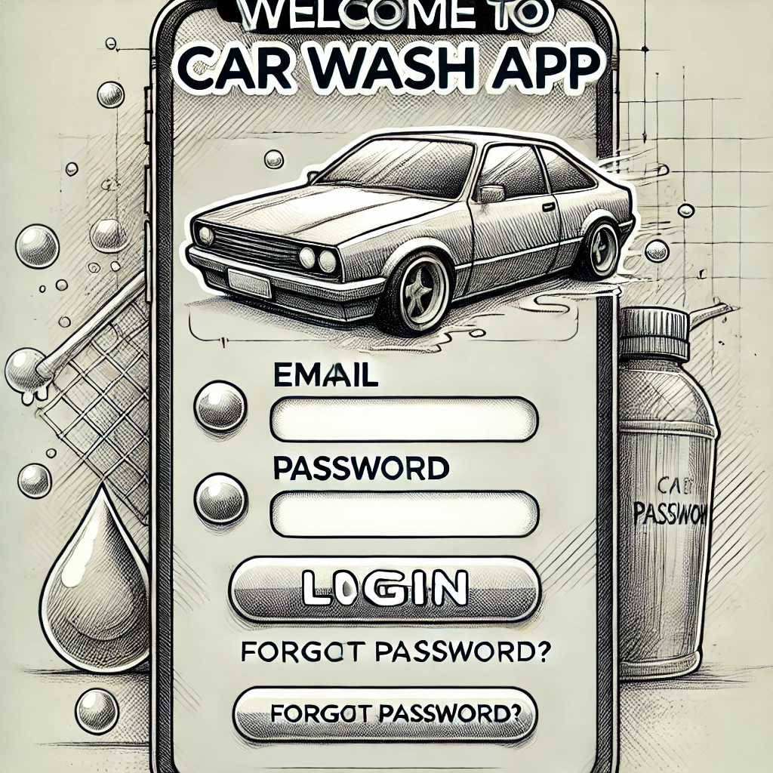

Home Screen:
- Description: This screen would be the main screen after login. It could display:
  - A list of nearby car washes with their names, ratings, and brief descriptions.
  - A search bar to find specific car washes.
  - A "Book Now" button to quickly access the booking flow.
  - A "My Appointments" section to view upcoming and past appointments.
  - A "Profile" button to access user settings and preferences.

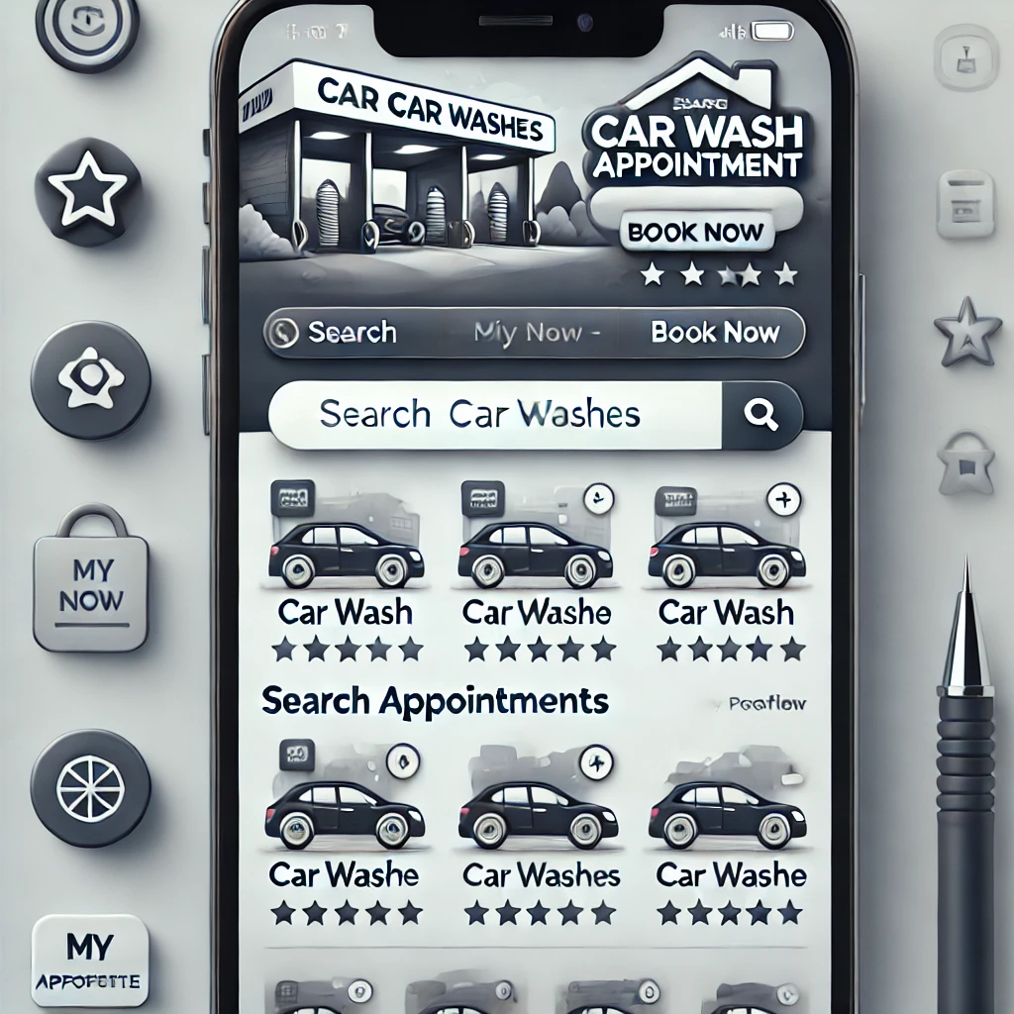

Car Wash Details Screen:
- Description: This screen would display detailed information about a selected car wash:
  - Car wash name and address
  - Contact information
  - List of services offered with prices
  - Customer ratings and reviews
  - "Book Now" button
  - Map showing the car wash location

Payment Screen:
- Description: This screen would allow users to select their preferred payment method and enter payment details:
  - List of available payment options (credit card, debit card, online wallets).
  - Secure input fields for payment information.
  - "Pay Now" button.

Appointment Confirmation Screen:
- Description: This screen would display a confirmation message after a successful booking:
  - Appointment details (date, time, services, car wash).
  - Booking confirmation number.
  - Option to view or print the confirmation.

Screen objects and actions
Login/Registration Screen
- Objects:
  - Username/Email Text Field
  - Password Text Field
  - Login Button
  - Register Button

- Actions:
  - Username/Email Field:
    - Action: User enters username or email.
  - Password Field:
    - Action: User enters password.
    - Validation: Check for password strength (if applicable).
  - Login Button:
    - Action: Initiate login process.
    - Validation: Check for empty fields.
  - Register Button:
    - Action: Navigate to registration screen.
  - Forgot Password Link:
    - Action: Navigate to password recovery screen.
2. Home Screen
- Objects:
  - Car Wash List View
  - Search Bar
  - Book Now Button
  - My Appointments Button
  - Profile Button
- Actions:
  - Car Wash List View:
    - Action: Allow users to tap on a car wash to view details.
  - Search Bar:
    - Action: Allow users to search for car washes Deal by name.
  - Book Now Button:
    - Action: Navigate to the appointment booking screen.
  - My Appointments Button:
    - Action: Navigate to the appointments screen.
  - Profile Button:
    - Action: Navigate to the user profile screen.
3. Car Wash Details Screen
- Objects:
  - Car Wash Details
  - Service List
  - Price List
  - Customer Ratings and Reviews
  - Book Now Button
- Actions:
  - Service List:
    - Action: Display a list of services offered by the car wash.
  - Price List:
    - Action: Display the prices for each service.
  - Customer Ratings and Reviews:
    - Action: Display average rating and user reviews.
  - Book Now Button:
    - Action: Navigate to the appointment scheduling screen with pre-selected car wash.
4. Appointment Booking Screen
- Objects:
  - Calendar View
  - Time Slot List
  - Service Selection Checkboxes
  - Confirm Booking Button
- Actions:
  - Calendar View:
    - Action: Allow users to select a date for the appointment.
  - Time Slot List:
    - Action: Display available time slots for the selected date.
    - Action: Allow users to select a preferred time slot.
  - Service Selection Checkboxes:
    - Action: Allow users to select the desired services.
  - Confirm Booking Button:
    - Action: Validate the selected date, time, and services.
    - Action: Navigate to the payment screen.
5. Payment Screen
- Objects:
  - Payment Method Selection.
  - Payment Details Input Fields.
  - Pay Now Button
- Actions:
  - Payment Method Selection:
    - Action: Allow users to select their preferred payment method.
  - Payment Details Input Fields:
    - Action: Allow users to enter payment details.
  - Pay Now Button:
    - Action: Process the payment securely.
    - Action: Display a confirmation message upon successful payment.
6. Appointment Confirmation Screen
- Objects:
  - Appointment Summary (date, time, services, car wash)
  - Booking Confirmation Number
  - View/Print Button
- Actions:
  - View/Print Button:
    - Action: Allow users to view or print the appointment confirmation.

Appendix I
    - How to design using UML (OOP): For guidance please follow the instructions mentioned in the link: http://agilemodeling.com/artifacts/
    - How and when to design ER diagrams: For guidance please follow the instructions mentioned in the link: http://people.inf.elte.hu/nikovits/DB2/Ullman_The_Complete_Book.pdf
    - Data flow diagrams: For guidance please follow the instructions mentioned in the link and book:
      - http://www.agilemodeling.com/artifacts/dataFlowDiagram.htm
      - Software Engineering –A Practitioner‟s approach by Roger Pressman
    - Architecture diagram: For guidance please follow the instructions mentioned in the link and book:
      - Ian Sommerville – Software Engineering 9th Edition– Chapter 6

